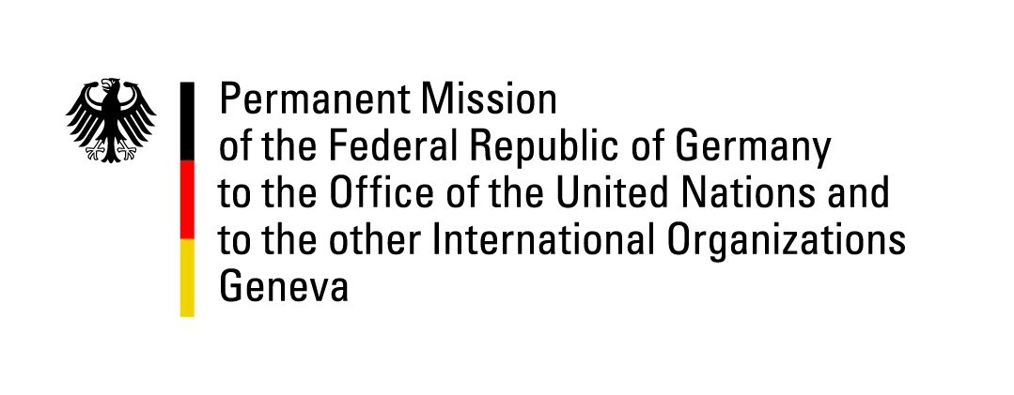

United Nations Human Rights Council
20th Session of the UPR Working Group

Geneva, 27 October 2014
---
German questions and recommendations to
El Salvador

National Statement
by
Germany

Thank you, Mr. President,

we welcome the progress made by the Government of El Salvador since its last UPR, particularly in the field of child labor. We encourage the Government of El Salvador to adopt a national action plan in this regard. Germany also acknowledges the progress made in the national reconciliation and peace-building process.

However, the human rights situation remains a concern. For example, according to UNICEF, El Salvador has the highest rate of homicide of children and adolescents worldwide, and the prison system is marred by overcrowding and inhuman conditions of detention.

Therefore, we would like to make the following recommendations to the Government of El Salvador:

- Germany recommends to the Government of El Salvador to take further steps to address victims’ rights, including taking forward reparations for victims of internal armed conflict, and to explore possible cooperation with United Nations special procedures mechanisms in that regard.

- Germany further recommends to the Government to develop a comprehensive policy to prevent violence against children, including all necessary measures to prevent children from being subject to torture and ill-treatment, to living and working in the street as well as being subjects to threats and forced recruitment by gangs. To this end, Germany recommends to strengthen implementation of the Law for Integral Protection of Children and Adolescents.

- Germany lastly recommends to El Salvador to adopt legislation on abortion that is in line with its international human rights obligations, taking into account indicators such as medical risks, rape, incest, and to ensure improved access to appropriate methods of contraception.

Thank you, Mr. President.

Questions in advance:

- In 2010, Germany recommended that El Salvador adopts efficient measures to stop child labor, especially in cases where children work in a hazardous environment. In this context, the German delegation would be interested to learn about measures so far taken by the Government to eliminate worst forms of child labor by 2015 and all forms of child labor by 2020?

- The criminalization of abortion causes high risks for women, in particular medical risks. In this context, we would like to ask the Government of El Salvador about measures taken to encourage and ensure the access to health services, sexual and reproductive health services in particular for women and girls?

- Germany is concerned about the alarming state of the prison system in El Salvador. Germany would like to know which measures have been taken by the Government to improve the conditions of detention and reduce over-crowding?

- Although legal steps to promote equality and non-discrimination based on gender-identity have been taken by the Government of El Salvador, discrimination against LGBTI persons remains widespread. Germany is interested in concrete measures and steps that have been taken by the Government to ensure the protection of transgender persons, in particular during detention and arrest?

